**BIG BASKET FORMS**

**NAME : HARSHITHA.T**

**ROLLNO: CB.SC.I5DAS21079**

1.USER REGISTRATION :

* This form enables the user to create login credentials to create an account to access the big basket application .

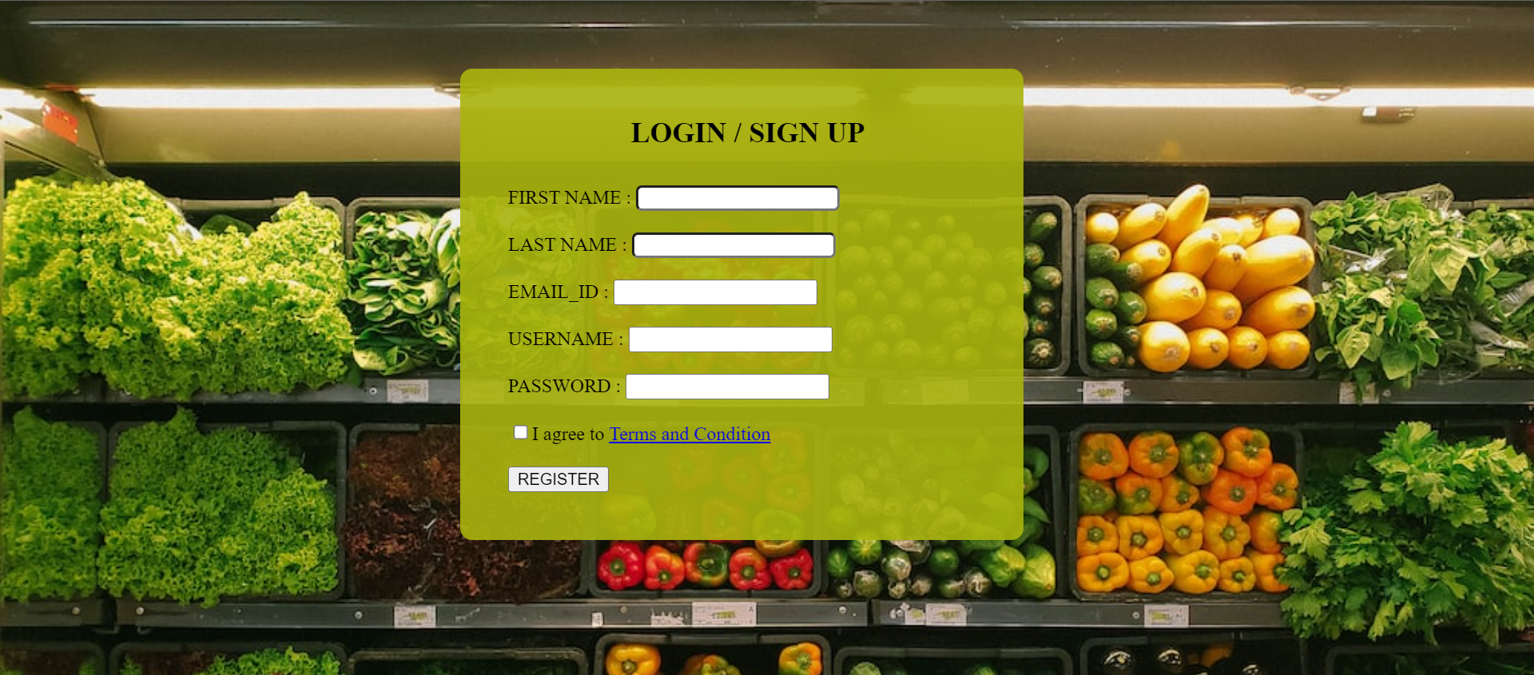

2.CUSTOMER DETAILS :

* In the customer form the customer will fill in his address, phone number, city, state, and pin-code. It provides the details of the customer.
* Once the customer registers he is then given access to shop in the app.
* He is allowed to choose from a variety of groceries, diary, bakery and so on.



3.PRODUCTS :

* Products form lists the products available in the application , the unit price of the product , the category under which it falls in .
* The customer can insert the products which he would like to pplace an order for .
* This form will provide the customer with product_id, product_name,description of the product .
* After filling this form the customer will navigate to the cart .



4.CART

* The customer can either add products to the cart , delete the product and update the quantities.
* Cart form will display the products that are purchased by the customer , It will list the products and the total amount to be paid .



5.PAYMENT METHOD :

* Once the items are added to the cart , the customer checks the cart , the total amount to be paid.
* The user is directed to the payment gateway , where the user chooses through which method he has to pay.



6.ORDER :

* The user will navigate from the payment to the order form, only if the payment has been successful.
* If the payment fails, the customer has to pay again.
* This form confirms the order, assures delivery.

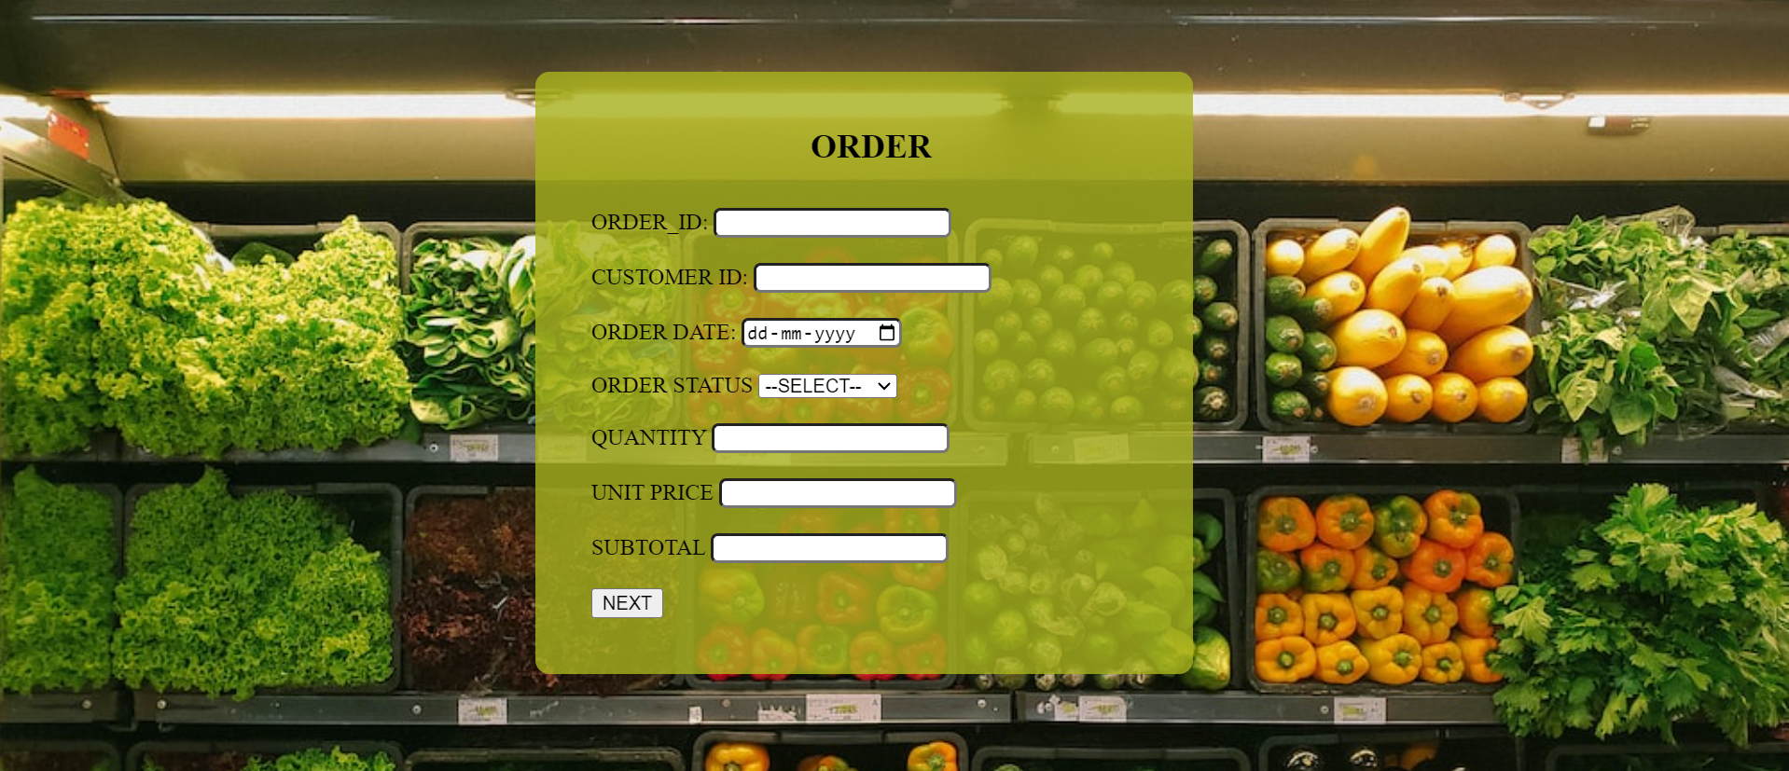

7.DELIVERY STATUS :

* This tracks the delivery of the package , after the order is placed .
* The customer will be asked to enter the customer_id , and order_id.



8.REVIEW :

* This form allows the customer to review the product purchased ,
* It allows them to edit the review , add rating .



9.PROMO :

* The more number of orders placed , the customer will be provided with promo codes
* Promo code may be applicable for the first order .
* But it is available only for a particular period of time.

